National University of Computer and Emerging Sciences



Quiz - 2

DAV lab

Department of Computer Science
FAST-NU, Lahore, Pakistan

Make a Soccer PlayerWeight PieChart (10 Marks)
Consider the following dataset: fifa_data.csv
Make a pie chart using Plotly, similar to the one shown below:

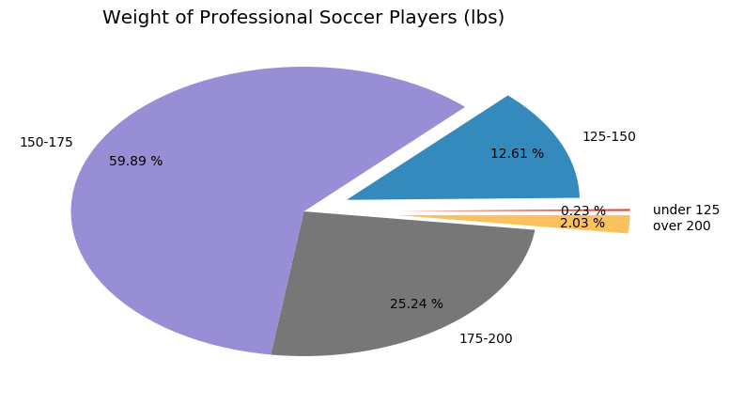

Create a Histogram, Bar-graph, and Box plot as well. (15 Marks)

Submission Instructions
Always read the submission instructions carefully.
- Put all your code in 1 Jupyter notebook.
- Rename your Jupyter notebook to your roll number and download the notebook as .ipynb extension.
- To download the required file, go to File->Download .ipynb
- Only submit the .ipynb file. DO NOTzip or rar your submission file
- Submit this file on Google Classroom under the relevant assignment.
- Late submissions will not be accepted

